

**Final Project Phase 1**

Makenzie Howard, Vidhi Arun Sharma, Willie Watts, Alissa Yang

MET AD 599S O2 - Introduction to Python and SQL for Business Analytics

August 5, 2025

**Table of Contents**

Introduction: 3

Part 1: Employee Sales Performance Analysis 3

Part 2: Monthly Sales Trend Analysis 4

Part 3: Product Sales Ranking by Category 9

Part 4: Customer Purchase Behavior Analysis 9

Conclusion: 12

# **Introduction:**

In this project, Northwind Traders has been assigned to analyze the sales performance of an international gourmet food distributor. The team will be analyzing multiple different metrics including specific employee performance, monthly sales trends, product sales rankings, and customer purchase behavior. For Phase 1, we will be utilizing SQL exclusively to organize our data and provide meaningful insights into the food distributor’s performance from 2012 to 2023. In doing so, the team will be able to provide data-informed insights and suggestions into how the company can improve profit margins through various means such as resource allocation and sales strategy.

# **Part 1: Employee Sales Performance Analysis**

To identify top-performing employees based on their total sales, the first task is to calculate the total sales amount for each employee. The query calculates the total sales generated by each employee by summing the sales values of their orders and takes into account quantity and discounts. The below result is a list of employees with their total sales and corresponding employee ID.

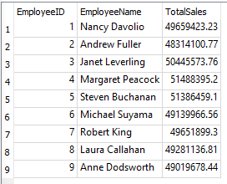

The second task is to rank employees based on their total sales performance. The query calculates total sales for each employee by summing the value of their order items and takes into account the discounts. It ranks the employees using RANK().

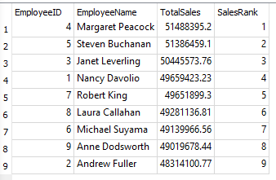

# **Part 2: Monthly Sales Trend Analysis**

To analyze monthly sales trends, we calculated the aggregate total sales for each month from July 2012 to October 2023 for a broad outlook on overall sales productivity. The query used calculates the total monthly sales revenue from all orders in the database. It joins the Orders table with the Order Details table to access both order dates and detailed line items. The result is grouped by month and ordered chronologically, enabling trend analysis across the sales timeline.

Our team then calculated the month-over-month sales growth as a percentage to better visualize and identify any sales surges, declines, and overall trends of the business. In addition to each month’s total sales, a measurement was added to calculate the month-over-month behavior by computing the percentage change in sales from one month to the next. From what we can understand so far, the company’s sales performance is displaying a consistently volatile outlook. This volatility could be due to certain factors such as seasonality surrounding certain products generating a holiday demand and post-holiday slowdowns. Although volatile throughout the year, high demand around certain months containing holidays followed by a steep dropoff remains a consistent trend.

*Both aggregate monthly sales as well as month-over-month growth have been merged together in the table below:*

| **YearMonth** | **TotalSales** | **MoMGrowthPercent** |
| --- | --- | --- |
| 2012-07 | 2066219.4 |  |
| 2012-08 | 3556875.79 | 72.14 |
| 2012-09 | 3440144.98 | -3.28 |
| 2012-10 | 3201529.96 | -6.94 |
| 2012-11 | 2980494.74 | -6.9 |
| 2012-12 | 3577936.85 | 20.05 |
| 2013-01 | 3075418.29 | -14.04 |
| 2013-02 | 2964192.86 | -3.62 |
| 2013-03 | 3471361.21 | 17.11 |
| 2013-04 | 3262893.52 | -6.01 |
| 2013-05 | 3593528.01 | 10.13 |
| 2013-06 | 2976184.24 | -17.18 |
| 2013-07 | 4275068.43 | 43.64 |
| 2013-08 | 2987993.36 | -30.11 |
| 2013-09 | 2671413.23 | -10.6 |
| 2013-10 | 3112262.1 | 16.5 |
| 2013-11 | 3042197.05 | -2.25 |
| 2013-12 | 3200607.71 | 5.21 |
| 2014-01 | 2710443.83 | -15.31 |
| 2014-02 | 2602658.47 | -3.98 |
| 2014-03 | 3854314.06 | 48.09 |
| 2014-04 | 3340038.66 | -13.34 |
| 2014-05 | 3267340.26 | -2.18 |
| 2014-06 | 3680115.42 | 12.63 |
| 2014-07 | 3178414.39 | -13.63 |
| 2014-08 | 3416670.63 | 7.5 |
| 2014-09 | 2694898.33 | -21.13 |
| 2014-10 | 3125850.74 | 15.99 |
| 2014-11 | 3156916.6 | 0.99 |
| 2014-12 | 3842486.74 | 21.72 |
| 2015-01 | 3421656.38 | -10.95 |
| 2015-02 | 2956201.14 | -13.6 |
| 2015-03 | 3353227.79 | 13.43 |
| 2015-04 | 3207293.13 | -4.35 |
| 2015-05 | 3425430.69 | 6.8 |
| 2015-06 | 2975668.32 | -13.13 |
| 2015-07 | 3636472.82 | 22.21 |
| 2015-08 | 4372619.01 | 20.24 |
| 2015-09 | 3390593.89 | -22.46 |
| 2015-10 | 3456874.61 | 1.95 |
| 2015-11 | 3249120.89 | -6.01 |
| 2015-12 | 3978298.05 | 22.44 |
| 2016-01 | 3658051.75 | -8.05 |
| 2016-02 | 3186904.49 | -12.88 |
| 2016-03 | 3662692.07 | 14.93 |
| 2016-04 | 2975703.27 | -18.76 |
| 2016-05 | 3437922.47 | 15.53 |
| 2016-06 | 3292493.54 | -4.23 |
| 2016-07 | 3669700.165 | 11.46 |
| 2016-08 | 3284795.995 | -10.49 |
| 2016-09 | 3331124.5 | 1.41 |
| 2016-10 | 3262160.375 | -2.07 |
| 2016-11 | 3152849.905 | -3.35 |
| 2016-12 | 3654273.83 | 15.9 |
| 2017-01 | 3446154.51 | -5.7 |
| 2017-02 | 2596633.885 | -24.65 |
| 2017-03 | 3823316.56 | 47.24 |
| 2017-04 | 3018989.7425 | -21.04 |
| 2017-05 | 4364953.01 | 44.58 |
| 2017-06 | 2995440.2425 | -31.38 |
| 2017-07 | 2885691.8075 | -3.66 |
| 2017-08 | 3341024.17 | 15.78 |
| 2017-09 | 2807367.7525 | -15.97 |
| 2017-10 | 3969991.476 | 41.41 |
| 2017-11 | 3618368.419 | -8.86 |
| 2017-12 | 3341972.6585 | -7.64 |
| 2018-01 | 4051026.5705 | 21.22 |
| 2018-02 | 3004052.9275 | -25.84 |
| 2018-03 | 2691888.005 | -10.39 |
| 2018-04 | 3087145.3625 | 14.68 |
| 2018-05 | 3248964.5605 | 5.24 |
| 2018-06 | 3242359.68 | -0.2 |
| 2018-07 | 2901454.46 | -10.51 |
| 2018-08 | 3286136.44 | 13.26 |
| 2018-09 | 3424899.45 | 4.22 |
| 2018-10 | 2789791.96 | -18.54 |
| 2018-11 | 3113044.9 | 11.59 |
| 2018-12 | 3485859.11 | 11.98 |
| 2019-01 | 3151757.32 | -9.58 |
| 2019-02 | 2895952.31 | -8.12 |
| 2019-03 | 3190906.85 | 10.19 |
| 2019-04 | 3578994.95 | 12.16 |
| 2019-05 | 3562283.98 | -0.47 |
| 2019-06 | 3241453.16 | -9.01 |
| 2019-07 | 3163267.4 | -2.41 |
| 2019-08 | 3078770.82 | -2.67 |
| 2019-09 | 3093903.19 | 0.49 |
| 2019-10 | 3346327.82 | 8.16 |
| 2019-11 | 2817565.99 | -15.8 |
| 2019-12 | 3395780.07 | 20.52 |
| 2020-01 | 3423774.29 | 0.82 |
| 2020-02 | 3467644.26 | 1.28 |
| 2020-03 | 3018709.85 | -12.95 |
| 2020-04 | 2655472.57 | -12.03 |
| 2020-05 | 3122293.71 | 17.58 |
| 2020-06 | 2871344.17 | -8.04 |
| 2020-07 | 3643366.59 | 26.89 |
| 2020-08 | 3794089.55 | 4.14 |
| 2020-09 | 3783178.34 | -0.29 |
| 2020-10 | 3060490.64 | -19.1 |
| 2020-11 | 2968195.35 | -3.02 |
| 2020-12 | 3053877.47 | 2.89 |
| 2021-01 | 3474864.06 | 13.79 |
| 2021-02 | 2953519.5 | -15 |
| 2021-03 | 3434464.48 | 16.28 |
| 2021-04 | 3255793.01 | -5.2 |
| 2021-05 | 3319860.71 | 1.97 |
| 2021-06 | 3510713.08 | 5.75 |
| 2021-07 | 3917400.08 | 11.58 |
| 2021-08 | 3443530.09 | -12.1 |
| 2021-09 | 3186946.18 | -7.45 |
| 2021-10 | 3071772.86 | -3.61 |
| 2021-11 | 3408890.29 | 10.97 |
| 2021-12 | 4377795.4 | 28.42 |
| 2022-01 | 3591353.72 | -17.96 |
| 2022-02 | 2832321.16 | -21.13 |
| 2022-03 | 3222005.69 | 13.76 |
| 2022-04 | 2628034.83 | -18.43 |
| 2022-05 | 3719270.11 | 41.52 |
| 2022-06 | 3378131.17 | -9.17 |
| 2022-07 | 3358177.3 | -0.59 |
| 2022-08 | 3660257.83 | 9 |
| 2022-09 | 2606755.13 | -28.78 |
| 2022-10 | 3717586.61 | 42.61 |
| 2022-11 | 3542815.27 | -4.7 |
| 2022-12 | 3485357.36 | -1.62 |
| 2023-01 | 3171802.16 | -9 |
| 2023-02 | 2611606.16 | -17.66 |
| 2023-03 | 3716250.41 | 42.3 |
| 2023-04 | 3474940.3 | -6.49 |
| 2023-05 | 3896544.35 | 12.13 |
| 2023-06 | 3071787.73 | -21.17 |
| 2023-07 | 3350337.36 | 9.07 |
| 2023-08 | 3293158.67 | -1.71 |
| 2023-09 | 3544698.51 | 7.64 |
| 2023-10 | 2923364.35 | -17.53 |

# **Part 3: Product Sales Ranking by Category**

# Looking at the top-selling products by category, it’s clear that total revenue is not always tied to the number of units sold. In Beverages, for example, Côte de Blaye earned the most even though Ipoh Coffee and Chang sold similar or more units. The same pattern appears in other categories too. In Confections, Sir Rodney’s Marmalade brought in the highest sales, while in Dairy Products, Raclette Courdavault came out on top. These products likely have higher prices, which makes them more profitable even if they don’t sell the most. This shows that Northwind should pay attention to both price and volume when planning what to promote or stock, especially if the goal is to improve profit, not just push more products.

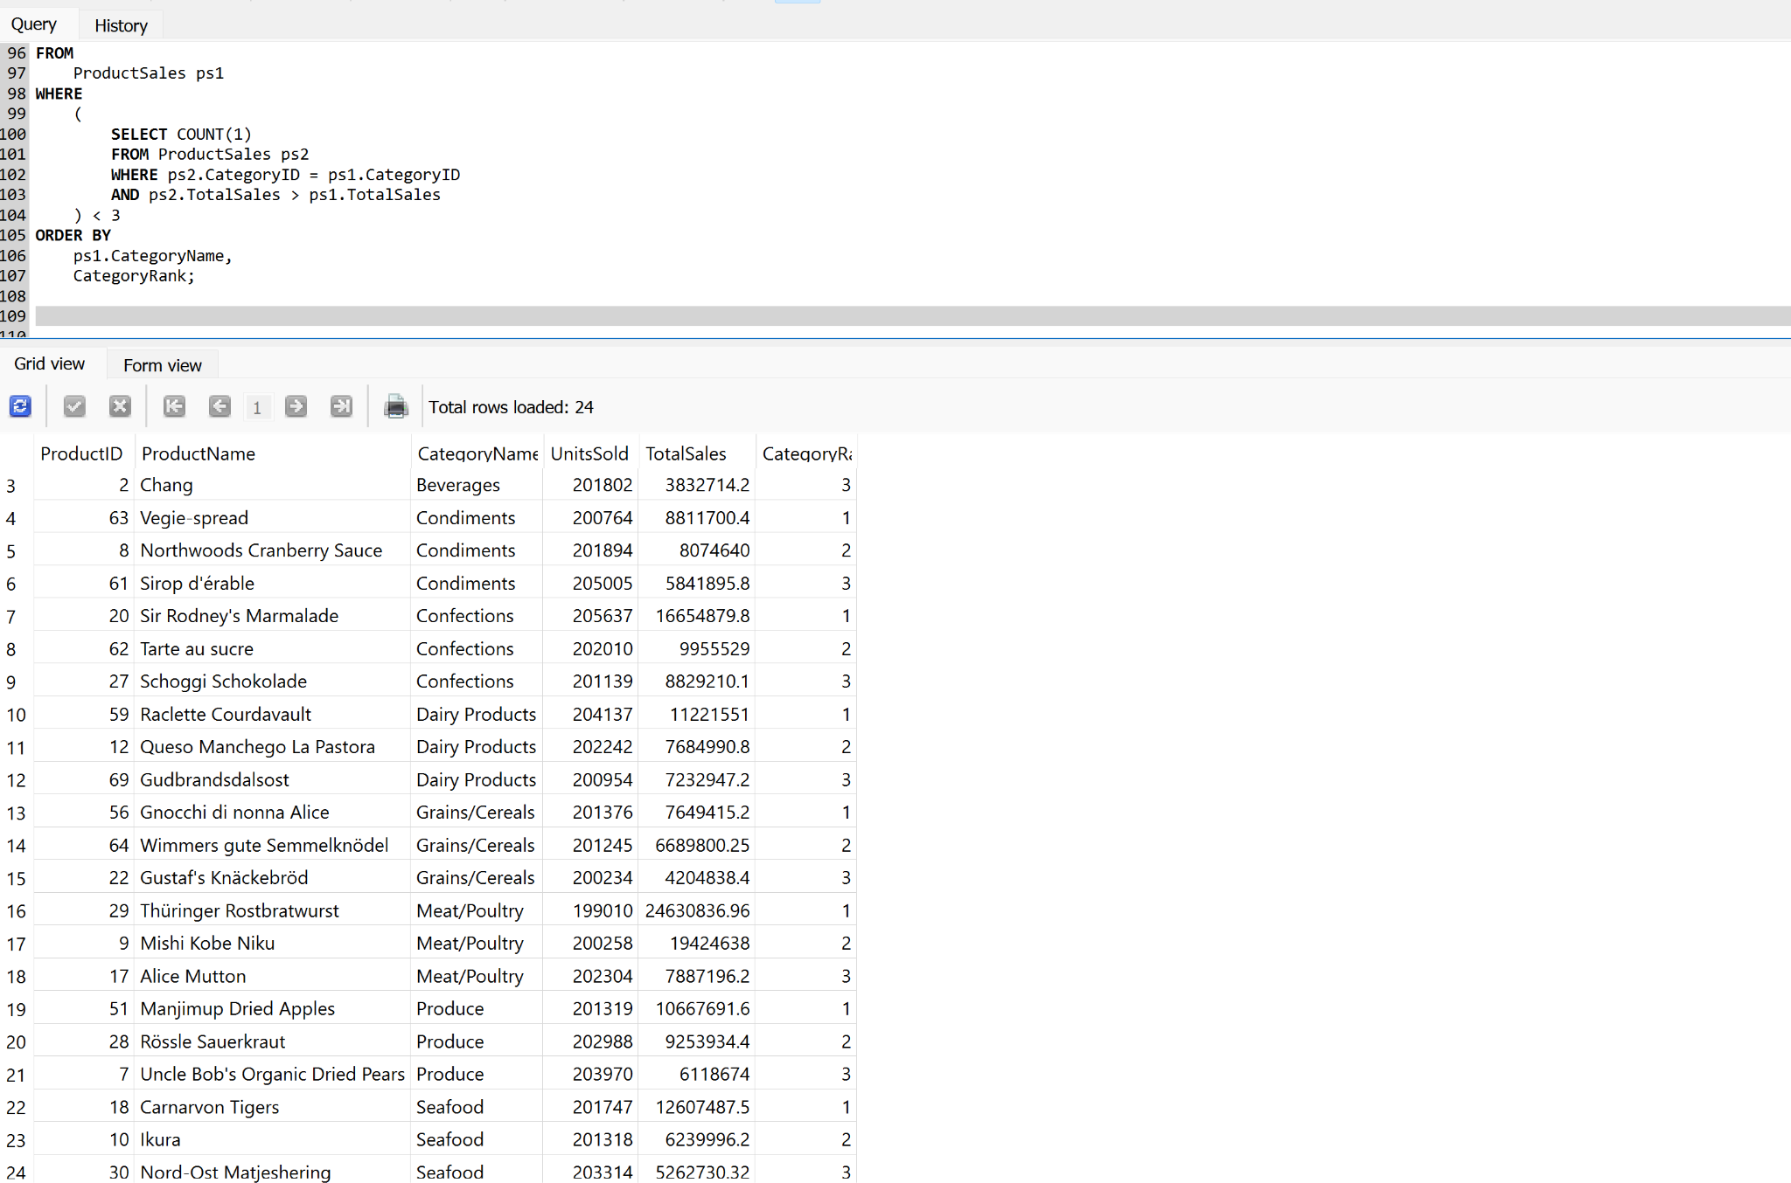

| ProductID | ProductName | CategoryID | CategoryName | UnitsSold | TotalSales | CategoryRank |
| --- | --- | --- | --- | --- | --- | --- |
| 38 | Côte de Blaye | 1 | Beverages | 202234 | 53274482.7 | 1 |
| 43 | Ipoh Coffee | 1 | Beverages | 202968 | 9334927.2 | 2 |
| 2 | Chang | 1 | Beverages | 201802 | 3832714.2 | 3 |
| 63 | Vegie-spread | 2 | Condiments | 200764 | 8811700.4 | 1 |
| 8 | Northwoods Cranberry Sauce | 2 | Condiments | 201894 | 8074640 | 2 |
| 61 | Sirop d'érable | 2 | Condiments | 205005 | 5841895.8 | 3 |
| 20 | Sir Rodney's Marmalade | 3 | Confections | 205637 | 16654879.8 | 1 |
| 62 | Tarte au sucre | 3 | Confections | 202010 | 9955529 | 2 |
| 27 | Schoggi Schokolade | 3 | Confections | 201139 | 8829210.1 | 3 |
| 59 | Raclette Courdavault | 4 | Dairy Products | 204137 | 11221551 | 1 |
| 12 | Queso Manchego La Pastora | 4 | Dairy Products | 202242 | 7684990.8 | 2 |
| 69 | Gudbrandsdalsost | 4 | Dairy Products | 200954 | 7232947.2 | 3 |
| 56 | Gnocchi di nonna Alice | 5 | Grains/Cereals | 201376 | 7649415.2 | 1 |
| 64 | Wimmers gute Semmelknödel | 5 | Grains/Cereals | 201245 | 6689800.25 | 2 |
| 22 | Gustaf's Knäckebröd | 5 | Grains/Cereals | 200234 | 4204838.4 | 3 |
| 29 | Thüringer Rostbratwurst | 6 | Meat/Poultry | 199010 | 24630836.96 | 1 |
| 9 | Mishi Kobe Niku | 6 | Meat/Poultry | 200258 | 19424638 | 2 |
| 17 | Alice Mutton | 6 | Meat/Poultry | 202304 | 7887196.2 | 3 |
| 51 | Manjimup Dried Apples | 7 | Produce | 201319 | 10667691.6 | 1 |
| 28 | Rössle Sauerkraut | 7 | Produce | 202988 | 9253934.4 | 2 |
| 7 | Uncle Bob's Organic Dried Pears | 7 | Produce | 203970 | 6118674 | 3 |
| 18 | Carnarvon Tigers | 8 | Seafood | 201747 | 12607487.5 | 1 |
| 10 | Ikura | 8 | Seafood | 201318 | 6239996.2 | 2 |
| 30 | Nord-Ost Matjeshering | 8 | Seafood | 203314 | 5262730.32 | 3 |

# 

# 

# **Part 4: Customer Purchase Behavior Analysis**

To evaluate customer purchasing behavior, we calculated the average order value by aggregating line-item totals for each order and averaging them at the customer level. This required joining the Orders and OrderDetails tables to compute the total value of each order using UnitPrice, Quantity, and Discount. The resulting order-level subtotals were then grouped by CustomerID to determine the average spend per order, then displayed in descending order. Below is the resulting table.

| CustomerID | CompanyName | AverageOrderValue |
| --- | --- | --- |
| FISSA | FISSA Fabrica Inter. Salchichas S.A. | 30448.65 |
| PICCO | Piccolo und mehr | 30318.79 |
| Val2 | IT | 30316.21 |
| MORGK | Morgenstern Gesundkost | 30051.07 |
| PERIC | Pericles Comidas clásicas | 30010.78 |
| PARIS | Paris spécialités | 29850.85 |
| THECR | The Cracker Box | 29748.41 |
| MAISD | Maison Dewey | 29727.34 |
| BOLID | Bólido Comidas preparadas | 29659.69 |
| SIMOB | Simons bistro | 29611.76 |
| LAZYK | Lazy K Kountry Store | 29593.22 |
| LACOR | La corne d'abondance | 29550.21 |
| SANTG | Santé Gourmet | 29504.72 |
| THEBI | The Big Cheese | 29456.47 |
| BSBEV | B's Beverages | 29305.31 |
| FAMIA | Familia Arquibaldo | 29141.55 |
| VAFFE | Vaffeljernet | 28894.04 |
| WELLI | Wellington Importadora | 28831.93 |
| HUNGC | Hungry Coyote Import Store | 28777.9 |
| RANCH | Rancho grande | 28655.21 |
| LETSS | Let's Stop N Shop | 28597.9 |
| BLONP | Blondesddsl père et fils | 28521.08 |
| ANATR | Ana Trujillo Emparedados y helados | 28381.32 |
| HANAR | Hanari Carnes | 28321.9 |
| BONAP | Bon app' | 28297.52 |
| SEVES | Seven Seas Imports | 28272.85 |
| WARTH | Wartian Herkku | 28237.15 |
| FOLIG | Folies gourmandes | 28233.35 |
| SPECD | Spécialités du monde | 28182.29 |
| VICTE | Victuailles en stock | 28067.48 |
| VALON | IT | 27983.49 |
| COMMI | Comércio Mineiro | 27891 |
| MEREP | Mère Paillarde | 27871.31 |
| OTTIK | Ottilies Käseladen | 27747.02 |
| EASTC | Eastern Connection | 27745.32 |
| WANDK | Die Wandernde Kuh | 27741.58 |
| FRANR | France restauration | 27704.81 |
| GREAL | Great Lakes Food Market | 27688.19 |
| GROSR | GROSELLA-Restaurante | 27672.85 |
| RICSU | Richter Supermarkt | 27624.17 |
| MAGAA | Magazzini Alimentari Riuniti | 27622.34 |
| GALED | Galería del gastrónomo | 27609.36 |
| GOURL | Gourmet Lanchonetes | 27486.68 |
| CACTU | Cactus Comidas para llevar | 27472.49 |
| WILMK | Wilman Kala | 27429.51 |
| VINET | Vins et alcools Chevalier | 27419.08 |
| CONSH | Consolidated Holdings | 27395.6 |
| FRANK | Frankenversand | 27376.14 |
| BOTTM | Bottom-Dollar Markets | 27374.07 |
| QUEEN | Queen Cozinha | 27348.87 |
| TRAIH | Trail's Head Gourmet Provisioners | 27336.43 |
| OLDWO | Old World Delicatessen | 27325.33 |
| SUPRD | Suprêmes délices | 27277.7 |
| TOMSP | Toms Spezialitäten | 27270.56 |
| CHOPS | Chop-suey Chinese | 27263.16 |
| AROUT | Around the Horn | 27255.27 |
| RICAR | Ricardo Adocicados | 27214.37 |
| HILAA | HILARION-Abastos | 27198.45 |
| PRINI | Princesa Isabel Vinhos | 27183.85 |
| ROMEY | Romero y tomillo | 27174.83 |
| DRACD | Drachenblut Delikatessen | 27155.05 |
| BERGS | Berglunds snabbköp | 27153.92 |
| TRADH | Tradição Hipermercados | 27059 |
| QUICK | QUICK-Stop | 26988.94 |
| RATTC | Rattlesnake Canyon Grocery | 26941.47 |
| BLAUS | Blauer See Delikatessen | 26900.11 |
| FRANS | Franchi S.p.A. | 26867.29 |
| TORTU | Tortuga Restaurante | 26792.3 |
| LILAS | LILA-Supermercado | 26785.41 |
| WOLZA | Wolski Zajazd | 26770.99 |
| GODOS | Godos Cocina Típica | 26721.38 |
| LAUGB | Laughing Bacchus Wine Cellars | 26624.91 |
| SPLIR | Split Rail Beer & Ale | 26623.38 |
| DUMON | Du monde entier | 26476.3 |
| CENTC | Centro comercial Moctezuma | 26472.67 |
| ANTON | Antonio Moreno Taquería | 26452.6 |
| FURIB | Furia Bacalhau e Frutos do Mar | 26442.89 |
| ISLAT | Island Trading | 26408.37 |
| REGGC | Reggiani Caseifici | 26395.26 |
| OCEAN | Océano Atlántico Ltda. | 26357.66 |
| KOENE | Königlich Essen | 26108.33 |
| HUNGO | Hungry Owl All-Night Grocers | 26001.55 |
| NORTS | North/South | 25933.79 |
| LONEP | Lonesome Pine Restaurant | 25896.71 |
| FOLKO | Folk och fä HB | 25521.72 |
| WHITC | White Clover Markets | 25479.28 |
| LINOD | LINO-Delicateses | 25407.4 |
| LAMAI | La maison d'Asie | 25274.01 |
| LEHMS | Lehmanns Marktstand | 25205.69 |
| QUEDE | Que Delícia | 25196.45 |
| ALFKI | Alfreds Futterkiste | 24328.01 |
| ERNSH | Ernst Handel | 24288.01 |
| SAVEA | Save-a-lot Markets | 23789.82 |

Building on the previous analysis, we ranked customers by their average order value using a common table expression (CTE) and the RANK() window function. Each order’s value was first calculated and aggregated per customer, preserving per-order accuracy. The results were then ordered in descending sequence, and specific ranks of interest (2, 3, 5, 8, 12, 15, and 17) were extracted. The resulting table is shown below.

| CustomerID | CompanyName | AvgOrderValue | Rank |
| --- | --- | --- | --- |
| PICCO | Piccolo und mehr | 30318.79 | 2 |
| Val2 | IT | 30316.21 | 3 |
| PERIC | Pericles Comidas clásicas | 30010.78 | 5 |
| MAISD | Maison Dewey | 29727.34 | 8 |
| LACOR | La corne d'abondance | 29550.21 | 12 |
| BSBEV | B's Beverages | 29305.31 | 15 |
| VAFFE | Vaffeljernet | 28894.04 | 17 |

# 

# **Conclusion:**

In this phase of the project, we used SQL to analyze different aspects of Northwind Traders’ business. Each section focused on a specific area: employee sales performance, monthly sales trends, product rankings by category, and customer purchase behavior.

We found that a few employees consistently lead in total sales, which can help with performance tracking and team planning. The monthly sales data showed recurring spikes and drops, likely influenced by seasonal factors or holiday demand. This kind of trend analysis can help the company prepare better for high and low periods.

When ranking products by category, we noticed that some items with fewer units sold still brought in the highest revenue. This shows that pricing plays an important role and could guide future product and marketing strategies. The customer analysis highlighted top buyers based on average order value, pointing to potential opportunities for loyalty programs or personalized outreach.

These findings give a strong foundation for the next phase, where we’ll use Python to build on this analysis and generate even deeper insights.